|  |
| --- |
|  |
|  |
| |  |  | | --- | --- | | [Woodblock printing](http://en.wikipedia.org/wiki/Woodblock_printing) | 200 [CE](http://en.wikipedia.org/wiki/Common_Era) | | [Movable type](http://en.wikipedia.org/wiki/Movable_type) | 1040 | | [Printing press](http://en.wikipedia.org/wiki/Printing_press) | 1453 | | [Etching](http://en.wikipedia.org/wiki/Etching) | [c.](http://en.wikipedia.org/wiki/Circa) 1515 | | [Mezzotint](http://en.wikipedia.org/wiki/Mezzotint) | 1642 | | [Aquatint](http://en.wikipedia.org/wiki/Aquatint) | 1772 | | [Lithography](http://en.wikipedia.org/wiki/Lithography) | 1796 | | [Chromolithography](http://en.wikipedia.org/wiki/Chromolithography) | 1837 | | [Rotary press](http://en.wikipedia.org/wiki/Rotary_printing_press) | 1843 | | [Hectograph](http://en.wikipedia.org/wiki/Hectograph) | 1869 | | [Offset printing](http://en.wikipedia.org/wiki/Offset_printing) | 1875 | | [Hot metal typesetting](http://en.wikipedia.org/wiki/Hot_metal_typesetting) | 1884 | | [Mimeograph](http://en.wikipedia.org/wiki/Mimeograph) | 1886 | | [Screen printing](http://en.wikipedia.org/wiki/Screen_printing) | 1910 | | [Spirit duplicator](http://en.wikipedia.org/wiki/Spirit_duplicator) | 1923 | | [Photocopying](http://en.wikipedia.org/wiki/Photocopying) | 1938 | | [Inkjet printing](http://en.wikipedia.org/wiki/Inkjet_printing) | 1951 | | [Dye-sublimation](http://en.wikipedia.org/wiki/Dye-sublimation_printer) | 1957 | | [Phototypesetting](http://en.wikipedia.org/wiki/Phototypesetting) | 1960s | | [Dot matrix printer](http://en.wikipedia.org/wiki/Dot_matrix_printer) | 1968 | | [Laser printing](http://en.wikipedia.org/wiki/Laser_printing) | 1969 | | [Thermal printing](http://en.wikipedia.org/wiki/Thermal_printer) | c. 1972 | | [3D printing](http://en.wikipedia.org/wiki/3D_printing) | 1984 | | [Digital press](http://en.wikipedia.org/wiki/Digital_printing) | 1993 | |

Dot-matrix printers

[](http://en.wikipedia.org/wiki/File:Dot_matrix_example_text.png)

[http://bits.wikimedia.org/static-1.23wmf9/skins/common/images/magnify-clip.png](http://en.wikipedia.org/wiki/File:Dot_matrix_example_text.png)

In the general sense many printers rely on a [matrix](http://en.wikipedia.org/wiki/Matrix_%28mathematics%29) of [pixels](http://en.wikipedia.org/wiki/Pixel), or [dots](http://en.wikipedia.org/wiki/Decimal_mark), that together form the larger image. However, the term [dot matrix printer](http://en.wikipedia.org/wiki/Dot_matrix_printer) is specifically used for impact printers that use a matrix of small [pins](http://en.wikipedia.org/wiki/Pin) to create precise dots. The advantage of dot-matrix over other impact printers is that they can produce [graphical](http://en.wikipedia.org/wiki/Graphic_design) images in addition to text; however the text is generally of poorer quality than impact printers that use letterform.

**Inkjet printing**

**Inkjet printing** is a type of [computer printing](http://en.wikipedia.org/wiki/Computer_printing) that creates a [digital image](http://en.wikipedia.org/wiki/Digital_image) by propelling droplets of ink onto paper, plastic, or other substrates. Inkjet printers are the most commonly used type of printer

**Laser printing**

**Laser printing** is an electrostatic [digital printing](http://en.wikipedia.org/wiki/Digital_printing) process that rapidly produces high quality text and graphics by passing a [laser beam](http://en.wikipedia.org/wiki/Laser_beam) over a charged drum to define a differentially charged image. The drum then selectively collects charged toner and transfers the image to paper, which is then heated to permanently fix the image.

## Printer does not have power indicator

First, make sure that the printer is on. When a printer is on it should have some light or [LED](http://www.computerhope.com/jargon/l/led.htm) (usually green) indicating it's receiving power and is on.

If you do not have any indicator light make sure the printer is connected to a working power outlet by verifying each end of the power cable. Next, press the printer power button.

If after following the above steps your printer still cannot get a power status indicator it's likely you're encountering a serious printer issue and we suggest contacting the [printer manufacturer](http://www.computerhope.com/network/printer.htm) for additional steps and instructions on repair or replacement.

## Cables not connected properly

Your printer should have two cables connected to it. The power cable and the data cable, the power cable should have already been verified as being connected if your printer has a power indicator light as mentioned above. Make sure the data cable ([parallel cable](http://www.computerhope.com/jargon/p/paraport.htm) or [USB](http://www.computerhope.com/jargon/u/usb.htm) cable) is also connected from the printer to the computer.

## Printer error (orange or blinking light)

After your printer has completed its initial startup you should have a solid green light. If the light indicator is blinking or orange often this is an indication of a printer error. For example, this could indicate a paper jam, issue with the ink or toner cartridge, or other serious error.

Because there is no standard to what a blinking light or orange light means if you're getting either of these we suggest referring to the printer documentation for troubleshooting steps or methods of determining what the status indicator is reporting.

## No paper or paper jam

Without paper your printer will not be able to print. Make sure you have paper in the paper loaded into the printer paper cartridge or tray. Next, verify that no printer paper is jammed or partially fed into the printer. If you have one or more pieces of paper stuck in the printer these will need to be manually removed before the printer will print again.

## Inkjet printer ink related issues

Often when you're encountering an ink related issue you're printer status indicator light (mentioned above) should be flashing. If this is not occurring you may want to skip to the next section. However, if you've recently inserted a new ink cartridge you may want to try the below suggestions.

* [Replacing ink cartridges and printer not working.](http://www.computerhope.com/issues/ch000084.htm)

## Printer self tests

Most printers have a way of printing a test page. This page allows you to determine if the printer is physically working or not. This test is usually accomplished by holding down a series of keys. If you are not sure if your printer has this feature or how to perform it refer to your manual

In addition to testing the printer using the printer self-test Microsoft Windows users can also perform a software self-test to determine if their computer is able to see the printer and it's able to print. Follow the below steps to perform this test.

**Microsoft Windows 98, 2000, ME, XP, 2003, and Vista users**

1. Click [Start](http://www.computerhope.com/jargon/s/start.htm), Settings, and open [Control Panel](http://www.computerhope.com/jargon/c/controlp.htm).
2. Double-click the Printers or Printers and Fax icon.
3. Right-click on the Printer you wish to test and click Properties. If you do not see your printer listed your printer is not installed.
4. In the Printers Properties window click the Print Test Page [button](http://www.computerhope.com/jargon/p/pushbutt.htm).
5. If the printer is able to print a test page, you're printer is installed and setup properly. However, if you're unable to print in other programs it's possible that the program you're attempting to print from has issues.

Older versions of Windows with older printers

If you are running an older printer and [MS-DOS](http://www.computerhope.com/msdos.htm), [Windows 3.x](http://www.computerhope.com/win3x.htm), [Windows 95](http://www.computerhope.com/win95.htm), [Windows 98](http://www.computerhope.com/win98.htm), or [Windows NT](http://www.computerhope.com/winnt.htm), you can also attempt the below software test.

[**Get to a MS-DOS prompt or Windows command line**](http://www.computerhope.com/issues/chdos.htm) **Get to the root directory -** Type: cd\  
**Reroute dir to printer -** Type: dir > lpt1

The above should take the directory listing and print to the printer. If this does not print, refer to your operating system troubleshooting section. Extra Note: This will not paper feed, therefore press your FF or PP, or manually eject the paper.

## Printer drivers

If your printer does not have any flashing lights and is connected properly it's possible you may be encountering a [driver](http://www.computerhope.com/jargon/d/driver.htm) related issue. We suggest visiting our [printer driver listing](http://www.computerhope.com/drivers/printers.htm), which links to all major printer manufacturer driver pages and downloading the latest printer drivers for your printer.

## Parallel (LPT) printers

If the printer you're connecting to the computer is an [LPT](http://www.computerhope.com/jargon/l/lpt.htm) (parallel port) printer we also suggest verifying the below suggestions if your printer is not working.

**Parallel port in CMOS**

1. [Enter the computers CMOS setup](http://www.computerhope.com/issues/ch000192.htm).
2. Once in CMOS verify that your parallel port is **enabled** or **installed**.
3. Next, verify the printer or parallel port mode. This option will often have several different modes. If your parallel port is set to ECP mode, we suggest trying a different mode.

**Other parallel device**

If you have a parallel printer with other parallel devices such as a parallel scanner or zip drive, temporarily disconnect these devices to verify they are not causing your issue.

# Setting up or installing a computer printer

Before a printer will work with your computer, you must install the software the included software. If you've lost the software for your printer, you can [download](http://www.computerhope.com/jargon/d/download.htm) the drivers for your printer and use the drivers to install your printer. A listing of printer manufacturers and links to their associated drivers pages can be found on our [printer drivers page](http://www.computerhope.com/drivers/printers.htm).

## Setup printer and install software

Every printer should come with the software used to install a printer in Windows or your operating system.

1. Connect the printer to the computer either using a [USB cable](http://www.computerhope.com/jargon/u/usb.htm), [parallel port cable](http://www.computerhope.com/jargon/p/paraport.htm), or [SCSI cable](http://www.computerhope.com/jargon/s/scsi.htm) and then connect the [power plug](http://www.computerhope.com/jargon/c/cable.htm) to a [power outlet](http://www.computerhope.com/jargon/o/outlet.htm).
2. After everything has been plugged in turn the computer on.
3. Insert the CD that was included with the printer. If the CD does not automatically start the install program open [My Computer](http://www.computerhope.com/jargon/m/mycomput.htm), double-click on the CD drive, and then the Setup or Install file. If you've downloaded the drivers, run the downloaded setup file.
4. Follow the installation wizard and your printer and its associated software should be installed successfully. After installed make sure to [test the printer](http://www.computerhope.com/issues/ch000250.htm#test).

## Installing a printer only using the drivers

In addition to the above steps, users can install a printer in Windows only using the printer [drivers](http://www.computerhope.com/jargon/d/driver.htm). This is recommended if you only want the printer to be installed, but not the additional printer software programs that are often included with the installation and you've download drivers.

A listing of printer drivers and software downloads can be found through our [printer drivers page](http://www.computerhope.com/drivers/printers.htm).

**Note:** if you've installed the printer doing the above steps these steps should not be necessary unless you encountered errors.

1. Connect the printer to the computer and a power outlet and make sure it's on.
2. Click Start, Settings, and [**Control Panel**](http://www.computerhope.com/jargon/c/controlp.htm).
3. In the control panel double-click the **Printers** or **Printers and Fax** icon.
4. In the Printers window, click the **Add a printer** icon.
5. After completing the above steps, the Windows Printer Wizard will appear. Click **Next** to start the wizard.
6. Windows will prompt you if you're installing a Local or Network printer. If the printer is connected to your computer choose **Local printer attached to this computer** and click **Next**.
7. When prompted for the location of the drivers for the printer. Browse the computer to the directory of your drivers or point it to the CD that was included with your printer.

## Testing the printer

After the printer has been installed, you can use Windows to print a self-test page to help verify the printer is working.

**Microsoft Windows users**

1. Click [Start](http://www.computerhope.com/jargon/s/start.htm), Settings, and open [Control Panel](http://www.computerhope.com/jargon/c/controlp.htm).
2. Double-click the Printers or Printers and Fax icon.
3. Right-click on the Printer you wish to test and click Properties. If you do not see your printer, your printer is not installed.
4. In the Printers Properties window, click the **Print Test Page** [button](http://www.computerhope.com/jargon/p/pushbutt.htm).
5. If the printer is able to print a test page, you're printer is installed and setup properly. However, if you're unable to print in other programs it's possible that the program you're attempting to print from has issues.

**10 Biggest Printer Problems -- And How To Fix Them**

By [Jeff Bertolucci](http://www.pcworld.com/author/Jeff-Bertolucci/), PCWorld

* Dec 18, 2009 3:06 PM
* [print](javascript://)
* [Single  
  Page](http://www.pcworld.com/article/185111/10_biggest_printer_problems_and_how_to_fix_them.html?page=0)

Printers: Can't live with them, can't nuke them. You could always toss a misbehaving inkjet or laser out the window, but where would that leave you? Truth be told, we need our printers, despite their maddening quirks. Here's a saner idea: Take a deep breath, channel your inner tech support rep, and repair that which has failed you. (*Cue sitar.*)

We've listed the 10 biggest printer annoyances -- of course, your Top 10 list may vary -- and ways to fix them.

**Problem:** Printing is too slow.

**[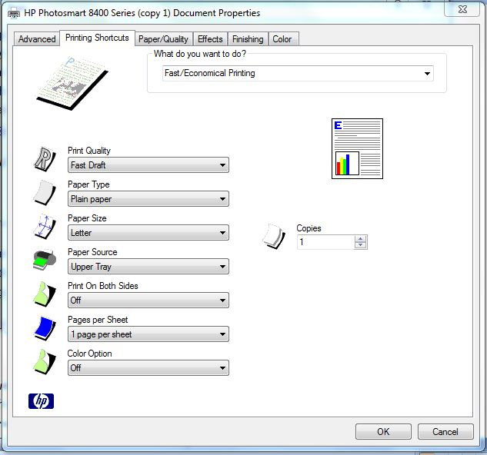](http://images.pcworld.com/news/graphics/185111-hpfastdraftprinting_original.jpg)Solution:** [Rev up printer performance](http://www.pcworld.com/article/181579-5/speed_up_everything.html)--and save ink in the process--by reducing print quality for everyday output. While printer settings vary by model, here's how to switch to draft-printing mode in most Windows apps. Select *Print* and *Properties*, and then look for a setting that reduces print quality. With the HP Photosmart 8450, for instance, change the default print quality setting from *Normal* to *Fast Draft* (click screen-shot at right). Other speedup suggestions: Print pages from websites without graphics, and add RAM to your printer, if possible. Read "[Speed Up Everything](http://www.pcworld.com/article/181579-5/speed_up_everything.html)" for more tips.

**Problem:** Ink and/or toner costs too much.

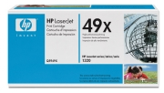**Solution:** PC World has written a lot about the printing industry's sneaky practices over the years. To wit: They snare you with dirt-cheap printers sold at or below cost, and then stick it to you later with ultra-pricey consumables.

Based on [our tests](http://www.pcworld.com/article/152953/how_much_ink_is_left_in_that_dead_cartridge.html), we can't recommend third party vendors' remanufactured or refilled ink cartridges, which may not give you your money's worth. One cost-saving solution is to [buy higher-capacity cartridges](http://www.pcworld.com/article/168955/is_your_printer_stealing_from_you_heres_how_to_tell.html). If you print a lot, try an ink cartridge with a 250-plus page yield, or a toner cartridge with a 2,000-plus page yield.

**Problem:** Windows is sending print jobs to the wrong printer.

[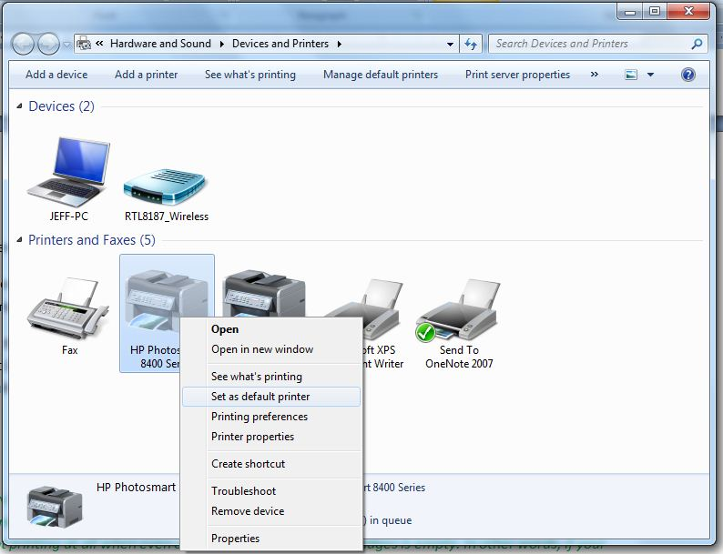](http://images.pcworld.com/news/graphics/185111-selectdefaultprinter_original.jpg)**Solution:** For some mysterious reason, Windows may select a new default printer--the one it automatically sends print jobs to. (This happened to me when I upgraded from Vista to Windows 7.) To fix this glitch in Windows 7, click *Start* (the Windows icon in the lower-left corner of the screen) and select *Devices and Printers*. Under Printers and Faxes, right-click the printer you want to make the default, and select *Set as default printer*.

If you're using earlier versions of Windows, these steps vary a bit. Here are instructions for Windows XP and [Vista](http://windows.microsoft.com/en-US/windows-vista/Change-your-default-printer) users.

**Problem:** My prints are too light, too spotty, or have horizontal lines.

[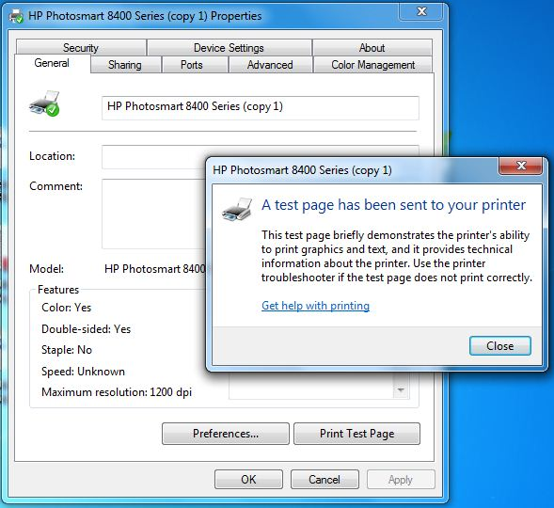](http://images.pcworld.com/news/graphics/185111-printingatestpage_original.jpg)**Solution:** You may have a clogged print head, a problem that can occur if you use an inkjet printer infrequently. Your printer's utility program can clean out the dried ink, and print a test page for inspection. The step-by-step instructions on how to do this vary by printer. From the Windows 7 Start menu, click *Devices and Printers* or *Control Panel*, and look for your printer's utility app. For additional details, read "[Solve Inkjet Printer Problems](http://www.pcworld.com/businesscenter/article/181912/solve_inkjet_printer_problems.html)." For more tips on unclogging ink nozzles, go [here.](http://www.pcworld.com/article/135907/more_printer_ink_tricks_from_readers.html) (Again, these steps may vary slightly for Vista and XP users.)

**Problem:** My printer says my ink cartridge is empty. I think it's lying.

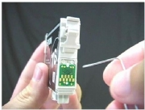**Solution:** You may be right. Printer out-of-ink messages are [notoriously unreliable](http://www.pcworld.com/article/152953/how_much_ink_is_left_in_that_dead_cartridge.html). The good news: You can try various hacks to get around those ink cartridge controls. We're not suggesting that all, or even some, of these [reader tips](http://www.pcworld.com/article/135907/more_printer_ink_tricks_from_readers.html) will work with your printer, but they're worth a try. One tip reveals how to [reset ink cartridges](http://www.inktec-uk.co.uk/57_58_reset.htm) for various HP printers. And a [video](http://www.walyou.com/blog/2009/02/26/inkjet-printer-ink-cartridge-trick/) on this page shows how to revive an "out of ink" Epson cartridge. If you're feeling adventurous, check them out.

**Problem:** My wireless printer is too slow.

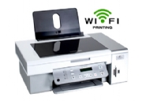**Solution:** To get the best performance from a network printer, it's hard to beat a wired, Ethernet-cable-to-router connection. Wireless printing may be more convenient in many homes and offices, but it has its limitations. Since Wi-Fi speeds slow down with distance, you'll want to place your wireless printer as [close as possible](http://www.pcworld.com/article/181579-5/speed_up_everything.html) to the router. Also, make sure your Wi-Fi printer or any wireless print server it connects to supports the [802.11n spec](http://www.pcworld.com/article/145098/new_80211n_routers_the_best_wifi_yet.html), which can rival the performance of 100-mbps Ethernet.

**Problem:** I use remanufactured or refilled ink cartridges, and my prints look awful.

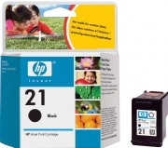**Solution:** We recommend [sticking with the manufacturer's ink](http://www.pcworld.com/article/182266/five_tips_for_better_photo_printing.html). Third-party products may save you money up front, but the consequences can get ugly--literally--if the cheaper inks produce lower-quality prints.

Here's another reason: wasted ink. The PC World Test Center has found that [some cartridges leave more than 40 percent](http://www.pcworld.com/article/152953/how_much_ink_is_left_in_that_dead_cartridge.html) of their ink unused. The worst offenders, unfortunately, are third-party brands. Printer manufacturers may overcharge shamelessly for ink, but at least you know what you're getting.

**Problem:** I don't know how to fit more text on one page. How do I do it?

**Solution:** Shrinking text to fit [two pages on one sheet](http://www.pcworld.com/article/181579-5/speed_up_everything.html) saves money (you'll buy less paper) and speeds up printing (fewer pages to print). This two-for-one approach is best for spreadsheets, receipts, and other documents that are still legible once shrunken.

In any Windows program, select *Print* and *Properties*, and then look for a printer setting that lets you increase the number of pages per sheet.

**Problem:** Grandma called and wants me to fix her "broken" printer. I'm no tech guru. What should I do?

**Solution:** You could always pretend you're not home, but that might lead to bigger problems down the line. We recommend you help Grandma out, because printer problems encountered by the, um, technically challenged are often easy to fix.

[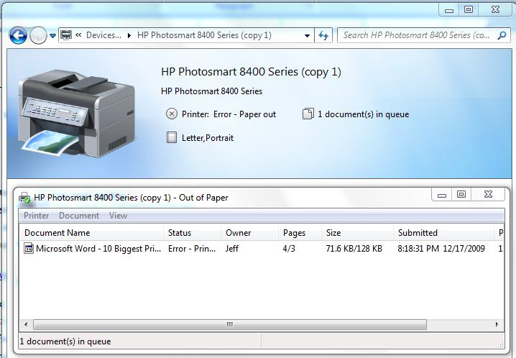](http://images.pcworld.com/news/graphics/185111-outofpapererror_original.jpg)First, have her see if the printer is plugged into a wall outlet. (Don't laugh. It's fairly common.) Second, she should make sure there's paper in the tray. And third, have her check the cable (probably USB or Ethernet) that connects the printer to the PC or router. This [troubleshooting basics](http://www.pcworld.com/businesscenter/article/168831/printer_troubleshooting_basics.html%202) article has more advice.

**Problem:** My paper tray is flimsy.

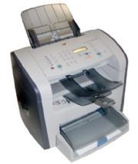**Solution:** To cut costs on some printers, vendors often include low-capacity or flimsy trays. In her article "[Is Your Printer Stealing From You?](http://www.pcworld.com/article/168955-2/is_your_printer_stealing_from_you_heres_how_to_tell.htmll)", PC World's Melissa Riofrio lists seven printers with notoriously cheap paper trays--each from major vendors such as Brother, Dell, Epson, HP, Ricoh, and Xerox. Shame on you guys.

So what can you do? Before buying a printer, examine the paper tray carefully. If it looks like it'll break after the first sideswipe, it's probably wise to get another model. If the tray is too small for your printing needs, see if there's a higher-capacity option. Or you could try [this guy's approach](http://www.youtube.com/watch?v=Rqp3EEPh004) to fixing a busted printer.